Ford Romania Intern Program
Internship Workplan
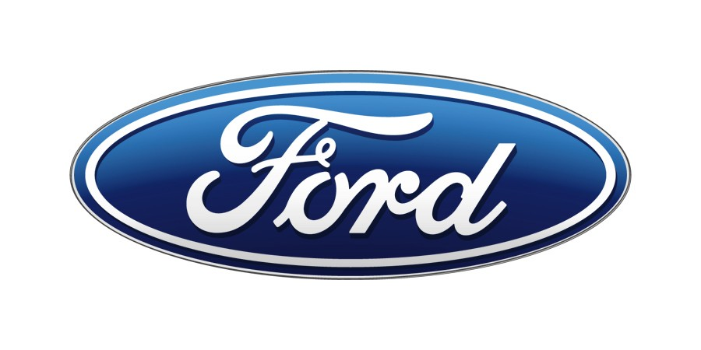

Project Name: | Removing swarf from the part on the Cylinder Head line on OP70 | Supervisor Name: | CALANGIU ADRIAN MARIUS
Department Name: | PTO/Machining | Supervisor CDSID: | ACALANGI
Assignment Location: | Craiova Engine Plant | Supervisor Position#: | PTM
Project Description

Presence of swarf in the cylinder head after washing operation in OP 70. This swarf influence pressing the correct guidelines in OP 80

Measurable Objectives

Complete removal of swarf during the process of washing and drying the part in OP 70

Expected Major Contributions

Washing and drying process improvement by implementing extra systems

Expected Benefits to Intern

To get familiar to workflow and processes in Ford Motor Company Machining department.

Intern Qualifications (schooling, work experience, major)

Machining engineering

