INSTRUCTIONS FOR PAPER PREPARATION (Times New Roman 14)
Name1 SURNAME1, Name2 SURNAME2 (Times New Roman 12)
Abstract: Each paper should have an abstract of 50-100 words, written in English. (Times New Roman 11)
1 Introduction (Times New Roman 12)
This document presents the layout and the technical requirements for the papers. The papers should have an even number of pages. They are to be written in Romanian or/and English language. Please use Microsoft Word in Windows and the styles accessible in the paper template.
Please do not create any additional styles. The file with the paper as a *.doc document should be sent by e-mail to the organising committee. (Times New Roman 12)
2 Detailed information (Times New Roman 12)
The figures are to be numbered sequentially Fig. 1, 2,... Each figure should be centred in the page.
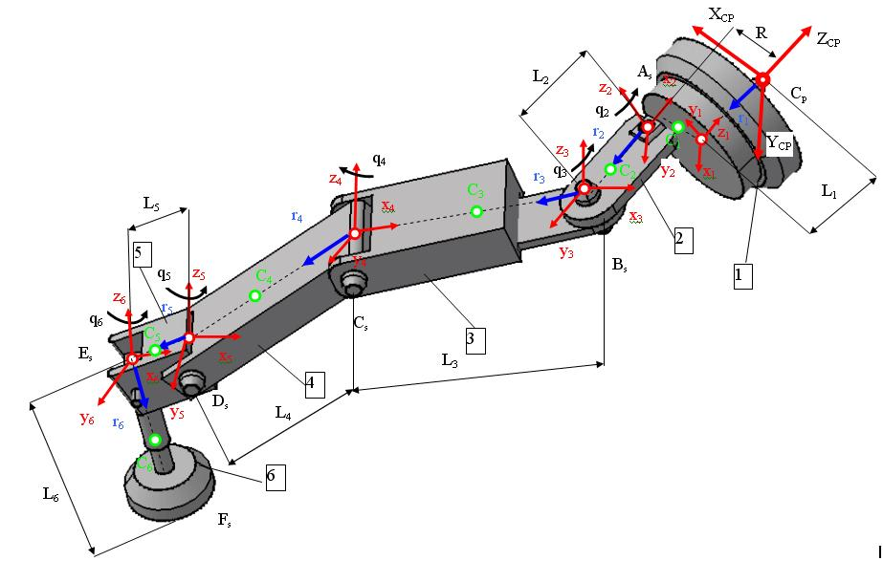
Fig. 1 Legend of the figure
Please create the equations in Microsoft Equation using the following settings: Normal – 12 pt, Indexes – 8 pt.
$r=\frac{l}{2\text{sin}\frac{π}{3}}=\frac{\text{47}}{2\text{sin}\frac{π}{3}}=\text{27}\text{.}\text{167}$ (1)
All the others remain unchanged.
2.1 Tables (Times New Roman 12)
The tables should be centred in the page.
Table 1 Legend of the table
References (Times New Roman 11)
- Dumitru N., Cherciu M., Zuhair A., Theoretical and experimental modeling of the dynamic response of the mechanisms with deformable kinematic elements, In: Proceedings of the 12th IFToMM world congress in mechanism and machine science, Vol. 4, Besancon (France), pp. 216 - 221, June 18-21, 2007. (Times New Roman 11)

All references have to be cited in the text by numbers in square brackets (i.e. [6-8], [1], [2, 5]) and appear in the list of References. All references from the list should also appear in the text.
Name1 SURNAME1 (Times New Roman 11)
Name of the institution
Address
E-mail

Name2 SURNAME2
Name of the institution
Address
E-mail

